15th January 2016

**YOKOHAMA Chelsea FC Edition tyre on display at Autosport International**

**The UK distributor for Japanese high performance and motorsport tyres, Yokohama HPT Ltd (YHPT), yesterday previewed the Chelsea FC Edition of the BluEarth-A AE-50 tyre to the UK market, at the annual Autosport International show.**

The Chelsea FC Edition of the BluEarth-A AE-50 tyre is a specially-branded version of YOKOHAMA´s successful environmental product aimed at fans of the world-famous English football Club. It follows the announcement prior to the start of this football season, of the partnership between YOKOHAMA and Chelsea FC, which saw the Japanese manufacturer become the 'Official shirt partner' of the premiership team.

The BluEarth range has been developed by YOKOHAMA to highlight its commitment to the environment and minimise the impact of tyre use and production. Therefore, it features a range of innovations, including the adoption of Orange Oil Technology within the compound, reducing the proportion of mineral oil content by replacing it with citrus oil from the skin of oranges.

It also features YOKOHAMA's lightweight design, as well as golf-ball sidewall dimples, to reduce aerodynamic drag and improve fuel efficiency.

The Chelsea FC Edition of the BluEarth-A AE-50 features the club's name and crest on the sidewall, making it an ideal choice for fans of the club or of football followers in general.

Commenting, YHPT Ltd Managing Director, David Seward, said; "I am delighted we are able to preview the Chelsea FC Edition tyre for the first time here in the UK. This is the first YOKOHAMA product to feature the Chelsea branding making the tyre an ideal choice not only for motorists who demand the best safety, performance and efficiency but also, would like to demonstrate their support for Chelsea FC."

Available in three sizes - 195/65R15, 205/55R16 and 225/45R17 - the Chelsea FC Edition tyre will be launched into the UK market in the coming weeks through YOKOHAMA´s nationwide network of dealers.

In addition to previewing the tyre, the 'Barclay's Premier League' trophy, held by Chelsea, will be on display on the YOKOHAMA stand at the Autosport International show on Thursday 14th and Friday 15th January, located in Hall 20, Stand No. 2750.

For more information, call 01908 625625 or go to [www.yokohama.co.uk](http://www.yokohama.co.uk).

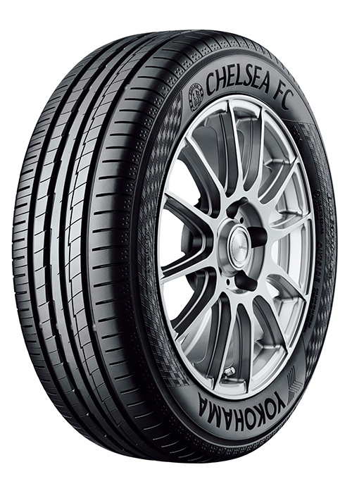

*The Chelsea FC Edition of the YOKOHAMA BluEarth-A AE-50 tyre*